|  |
| --- |
| The SAS System |

The REG Procedure

Model: MODEL1

Dependent Variable: Crime

|  |  |
| --- | --- |
| **Number of Observations Read** | 47 |
| **Number of Observations Used** | 47 |

| **Analysis of Variance** | | | | | |
| --- | --- | --- | --- | --- | --- |
| **Source** | **DF** | **Sum of Squares** | **Mean Square** | **F Value** | **Pr > F** |
| **Model** | 2 | 1268456 | 634228 | 4.97 | 0.0113 |
| **Error** | 44 | 5612472 | 127556 |  |  |
| **Corrected Total** | 46 | 6880928 |  |  |  |

|  |  |  |  |
| --- | --- | --- | --- |
| **Root MSE** | 357.15008 | **R-Square** | 0.1843 |
| **Dependent Mean** | 905.08511 | **Adj R-Sq** | 0.1473 |
| **Coeff Var** | 39.46039 |  |  |

| **Parameter Estimates** | | | | | | | |
| --- | --- | --- | --- | --- | --- | --- | --- |
| **Variable** | **DF** | **Parameter Estimate** | **Standard Error** | **t Value** | **Pr > |t|** | **95% Confidence Limits** | |
| **Intercept** | **1** | 1328.86662 | 298.11329 | 4.46 | <.0001 | 728.05876 | 1929.67448 |
| **Time** | **1** | -2.46658 | 8.25765 | -0.30 | 0.7666 | -19.10879 | 14.17563 |
| **Prob** | **1** | -7605.96938 | 2573.83103 | -2.96 | 0.0050 | -12793 | -2418.75378 |

|  |
| --- |
| The SAS System |

The REG Procedure

Model: MODEL1

Dependent Variable: Crime

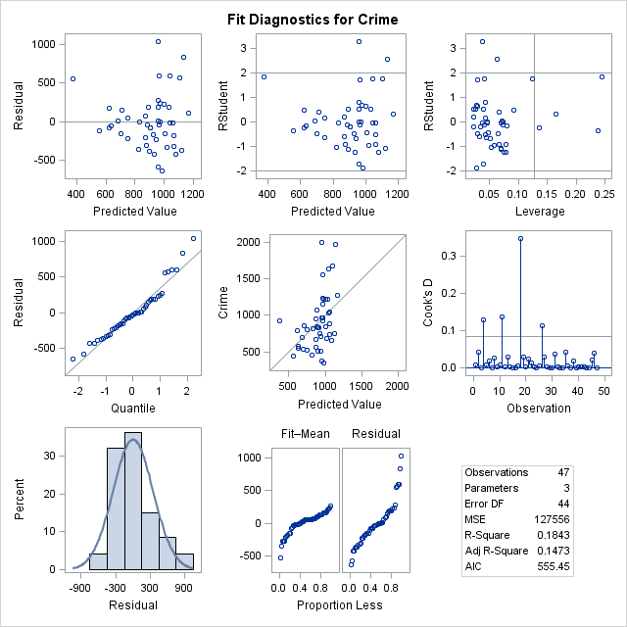

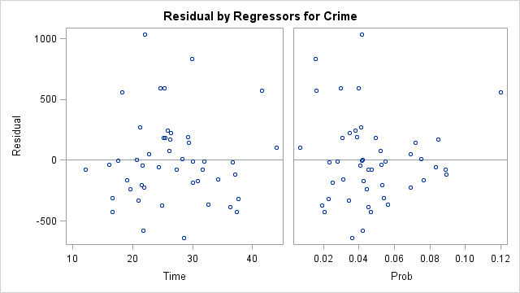

|  |
| --- |
| The SAS System |

The REG Procedure

Model: MODEL1

Dependent Variable: Crime

|  |  |
| --- | --- |
| **Number of Observations Read** | 47 |
| **Number of Observations Used** | 47 |

| **Analysis of Variance** | | | | | |
| --- | --- | --- | --- | --- | --- |
| **Source** | **DF** | **Sum of Squares** | **Mean Square** | **F Value** | **Pr > F** |
| **Model** | 10 | 5716241 | 571624 | 17.67 | <.0001 |
| **Error** | 36 | 1164686 | 32352 |  |  |
| **Corrected Total** | 46 | 6880928 |  |  |  |

|  |  |  |  |
| --- | --- | --- | --- |
| **Root MSE** | 179.86773 | **R-Square** | 0.8307 |
| **Dependent Mean** | 905.08511 | **Adj R-Sq** | 0.7837 |
| **Coeff Var** | 19.87302 |  |  |

| **Parameter Estimates** | | | | | | | |
| --- | --- | --- | --- | --- | --- | --- | --- |
| **Variable** | **DF** | **Parameter Estimate** | **Standard Error** | **t Value** | **Pr > |t|** | **95% Confidence Limits** | |
| **Intercept** | **1** | -8977.56264 | 1477.00057 | -6.08 | <.0001 | -11973 | -5982.06665 |
| **Time** | **1** | 0.81001 | 5.44190 | 0.15 | 0.8825 | -10.22667 | 11.84669 |
| **Prob** | **1** | -2627.64647 | 1771.38716 | -1.48 | 0.1467 | -6220.18614 | 964.89321 |
| **M** | **1** | 89.24880 | 29.54961 | 3.02 | 0.0046 | 29.31942 | 149.17818 |
| **Ed** | **1** | 165.09058 | 52.05371 | 3.17 | 0.0031 | 59.52076 | 270.66040 |
| **Po1** | **1** | 96.40794 | 14.31954 | 6.73 | <.0001 | 67.36656 | 125.44931 |
| **MpF** | **1** | 25.12316 | 12.27609 | 2.05 | 0.0481 | 0.22609 | 50.02023 |
| **LF** | **1** | 3468.28098 | 1596.46565 | 2.17 | 0.0365 | 230.49859 | 6706.06338 |
| **splinelf** | **1** | -8026.92579 | 2802.80203 | -2.86 | 0.0069 | -13711 | -2342.57981 |
| **ur** | **1** | 20.21479 | 6.53708 | 3.09 | 0.0038 | 6.95697 | 33.47260 |
| **Ineq** | **1** | 58.65506 | 13.05890 | 4.49 | <.0001 | 32.17039 | 85.13974 |

|  |
| --- |
| The SAS System |

The REG Procedure

Model: MODEL1

Dependent Variable: Crime

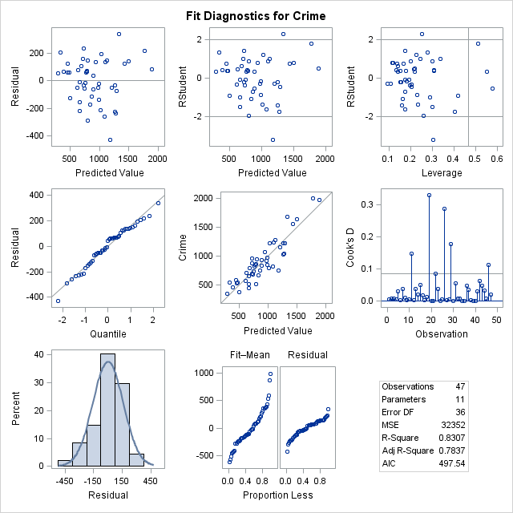

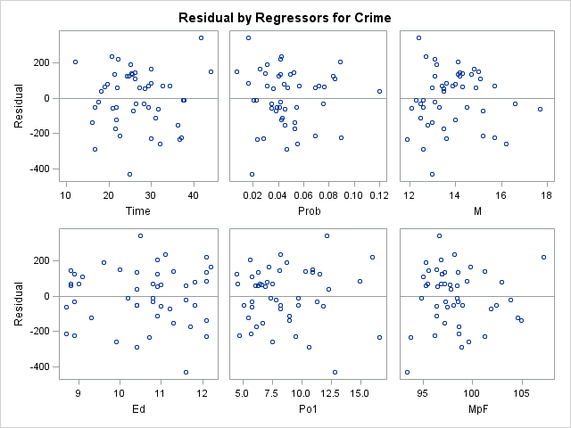

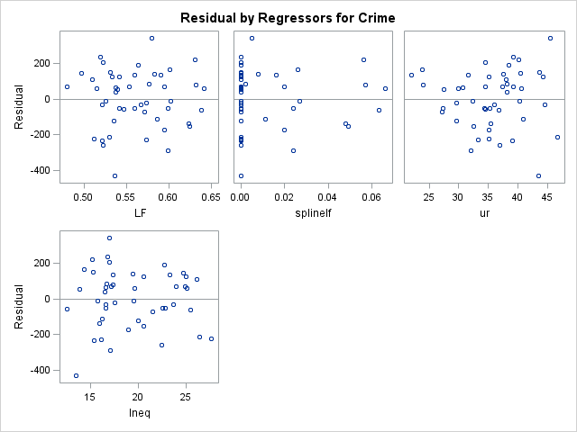

|  |
| --- |
| The SAS System |

The REG Procedure

Model: MODEL1

Dependent Variable: lcrime

|  |  |
| --- | --- |
| **Number of Observations Read** | 47 |
| **Number of Observations Used** | 47 |

| **Analysis of Variance** | | | | | |
| --- | --- | --- | --- | --- | --- |
| **Source** | **DF** | **Sum of Squares** | **Mean Square** | **F Value** | **Pr > F** |
| **Model** | 8 | 6.05551 | 0.75694 | 16.75 | <.0001 |
| **Error** | 38 | 1.71710 | 0.04519 |  |  |
| **Corrected Total** | 46 | 7.77261 |  |  |  |

|  |  |  |  |
| --- | --- | --- | --- |
| **Root MSE** | 0.21257 | **R-Square** | 0.7791 |
| **Dependent Mean** | 6.72494 | **Adj R-Sq** | 0.7326 |
| **Coeff Var** | 3.16095 |  |  |

| **Parameter Estimates** | | | | | | | |
| --- | --- | --- | --- | --- | --- | --- | --- |
| **Variable** | **DF** | **Parameter Estimate** | **Standard Error** | **t Value** | **Pr > |t|** | **95% Confidence Limits** | |
| **Intercept** | **1** | -0.99752 | 1.17233 | -0.85 | 0.4002 | -3.37077 | 1.37573 |
| **Time** | **1** | -0.00686 | 0.00587 | -1.17 | 0.2501 | -0.01875 | 0.00503 |
| **Prob** | **1** | -4.51740 | 1.99866 | -2.26 | 0.0296 | -8.56347 | -0.47132 |
| **M** | **1** | 0.13124 | 0.03501 | 3.75 | 0.0006 | 0.06036 | 0.20212 |
| **Ed** | **1** | 0.20630 | 0.05533 | 3.73 | 0.0006 | 0.09428 | 0.31831 |
| **Po1** | **1** | 0.08359 | 0.01935 | 4.32 | 0.0001 | 0.04442 | 0.12276 |
| **ur** | **1** | 0.02053 | 0.00766 | 2.68 | 0.0108 | 0.00502 | 0.03603 |
| **Wealth** | **1** | 0.00017775 | 0.00009891 | 1.80 | 0.0803 | -0.00002249 | 0.00037799 |
| **Ineq** | **1** | 0.08992 | 0.01868 | 4.81 | <.0001 | 0.05209 | 0.12774 |

|  |
| --- |
| The SAS System |

The REG Procedure

Model: MODEL1

Dependent Variable: lcrime

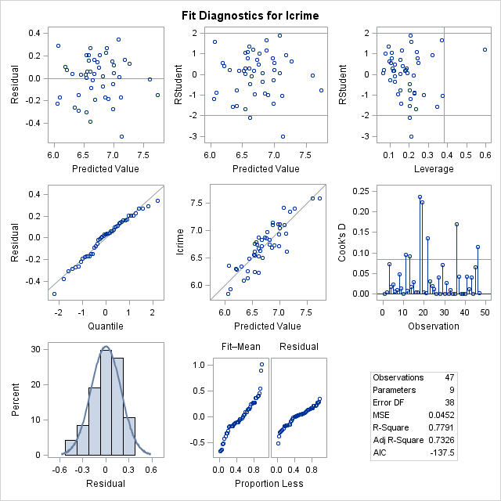

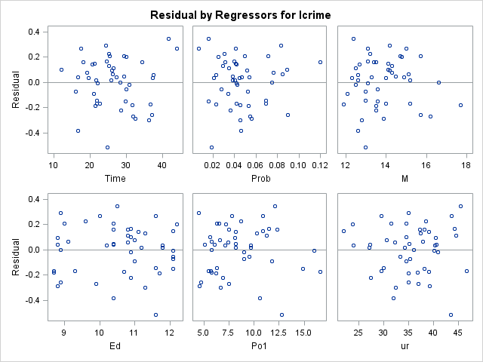

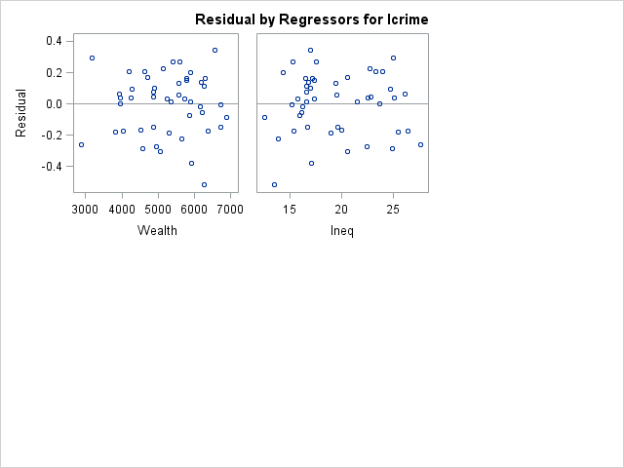

|  |
| --- |
| The SAS System |

The REG Procedure

Model: MODEL1

Dependent Variable: Crime

|  |  |
| --- | --- |
| **Number of Observations Read** | 47 |
| **Number of Observations Used** | 47 |

|  |
| --- |
|  |

|  |
| --- |
| **Stepwise Selection: Step 0** |

|  |
| --- |
| **First 2 Vars Entered: R-Square = 0.1843 and C(p) = 153.0316** |
|  |
|  |
|  |
|  |

| **Analysis of Variance** | | | | | |
| --- | --- | --- | --- | --- | --- |
| **Source** | **DF** | **Sum of Squares** | **Mean Square** | **F Value** | **Pr > F** |
| **Model** | 2 | 1268456 | 634228 | 4.97 | 0.0113 |
| **Error** | 44 | 5612472 | 127556 |  |  |
| **Corrected Total** | 46 | 6880928 |  |  |  |

|  | **Variable** | **Parameter Estimate** | **Standard Error** | **Type II SS** | **F Value** | **Pr > F** |
| --- | --- | --- | --- | --- | --- | --- |
|  | **Intercept** | 1328.86662 | 298.11329 | 2534554 | 19.87 | <.0001 |
| **\*** | **Time** | -2.46658 | 8.25765 | 11381 | 0.09 | 0.7666 |
| **\*** | **Prob** | -7605.96938 | 2573.83103 | 1113911 | 8.73 | 0.0050 |
| **\* Forced into the model by the INCLUDE= option** | | | | | | |

|  |
| --- |
| **Bounds on condition number: 1.235, 4.9402** |

|  |
| --- |
| **Stepwise Selection: Step 1** |

|  |
| --- |
| **Variable Po1 Entered: R-Square = 0.4872 and C(p) = 82.9900** |
|  |
|  |
|  |
|  |

| **Analysis of Variance** | | | | | |
| --- | --- | --- | --- | --- | --- |
| **Source** | **DF** | **Sum of Squares** | **Mean Square** | **F Value** | **Pr > F** |
| **Model** | 3 | 3352298 | 1117433 | 13.62 | <.0001 |
| **Error** | 43 | 3528629 | 82061 |  |  |
| **Corrected Total** | 46 | 6880928 |  |  |  |

|  | **Variable** | **Parameter Estimate** | **Standard Error** | **Type II SS** | **F Value** | **Pr > F** |
| --- | --- | --- | --- | --- | --- | --- |
|  | **Intercept** | 248.59322 | 321.13828 | 49174 | 0.60 | 0.4431 |
| **\*** | **Time** | 1.91144 | 6.68004 | 6718.94809 | 0.08 | 0.7761 |
| **\*** | **Prob** | -1938.75827 | 2350.87217 | 55812 | 0.68 | 0.4141 |
|  | **Po1** | 81.99416 | 16.27119 | 2083843 | 25.39 | <.0001 |
| **\* Forced into the model by the INCLUDE= option** | | | | | | |

|  |
| --- |
| **Bounds on condition number: 1.6016, 12.506** |

|  |
| --- |
| **Stepwise Selection: Step 2** |

|  |
| --- |
| **Variable Ineq Entered: R-Square = 0.6341 and C(p) = 50.0481** |
|  |
|  |
|  |
|  |

| **Analysis of Variance** | | | | | |
| --- | --- | --- | --- | --- | --- |
| **Source** | **DF** | **Sum of Squares** | **Mean Square** | **F Value** | **Pr > F** |
| **Model** | 4 | 4363013 | 1090753 | 18.19 | <.0001 |
| **Error** | 42 | 2517914 | 59950 |  |  |
| **Corrected Total** | 46 | 6880928 |  |  |  |

|  | **Variable** | **Parameter Estimate** | **Standard Error** | **Type II SS** | **F Value** | **Pr > F** |
| --- | --- | --- | --- | --- | --- | --- |
|  | **Intercept** | -664.91670 | 353.32759 | 212310 | 3.54 | 0.0668 |
| **\*** | **Time** | -7.50554 | 6.15302 | 89203 | 1.49 | 0.2293 |
| **\*** | **Prob** | -5411.64125 | 2180.11155 | 369396 | 6.16 | 0.0171 |
|  | **Po1** | 116.76534 | 16.28280 | 3082912 | 51.42 | <.0001 |
|  | **Ineq** | 53.19432 | 12.95528 | 1010715 | 16.86 | 0.0002 |
| **\* Forced into the model by the INCLUDE= option** | | | | | | |

|  |
| --- |
| **Bounds on condition number: 2.0498, 28.764** |

|  |
| --- |
| **Stepwise Selection: Step 3** |

|  |
| --- |
| **Variable Ed Entered: R-Square = 0.6999 and C(p) = 36.3863** |
|  |
|  |
|  |
|  |

| **Analysis of Variance** | | | | | |
| --- | --- | --- | --- | --- | --- |
| **Source** | **DF** | **Sum of Squares** | **Mean Square** | **F Value** | **Pr > F** |
| **Model** | 5 | 4816038 | 963208 | 19.13 | <.0001 |
| **Error** | 41 | 2064890 | 50363 |  |  |
| **Corrected Total** | 46 | 6880928 |  |  |  |

|  | **Variable** | **Parameter Estimate** | **Standard Error** | **Type II SS** | **F Value** | **Pr > F** |
| --- | --- | --- | --- | --- | --- | --- |
|  | **Intercept** | -3003.97948 | 844.46243 | 637304 | 12.65 | 0.0010 |
| **\*** | **Time** | -0.80463 | 6.06605 | 886.12141 | 0.02 | 0.8951 |
| **\*** | **Prob** | -3840.68782 | 2065.71308 | 174097 | 3.46 | 0.0702 |
|  | **Ed** | 149.43774 | 49.82601 | 453024 | 9.00 | 0.0046 |
|  | **Po1** | 116.06685 | 14.92598 | 3045397 | 60.47 | <.0001 |
|  | **Ineq** | 79.69723 | 14.80154 | 1460110 | 28.99 | <.0001 |
| **\* Forced into the model by the INCLUDE= option** | | | | | | |

|  |
| --- |
| **Bounds on condition number: 3.1851, 57.615** |

|  |
| --- |
| **Stepwise Selection: Step 4** |

|  |
| --- |
| **Variable M Entered: R-Square = 0.7394 and C(p) = 28.9900** |
|  |
|  |
|  |
|  |

| **Analysis of Variance** | | | | | |
| --- | --- | --- | --- | --- | --- |
| **Source** | **DF** | **Sum of Squares** | **Mean Square** | **F Value** | **Pr > F** |
| **Model** | 6 | 5087831 | 847972 | 18.92 | <.0001 |
| **Error** | 40 | 1793096 | 44827 |  |  |
| **Corrected Total** | 46 | 6880928 |  |  |  |

|  | **Variable** | **Parameter Estimate** | **Standard Error** | **Type II SS** | **F Value** | **Pr > F** |
| --- | --- | --- | --- | --- | --- | --- |
|  | **Intercept** | -3918.66819 | 879.04734 | 890833 | 19.87 | <.0001 |
| **\*** | **Time** | -2.75513 | 5.77753 | 10194 | 0.23 | 0.6361 |
| **\*** | **Prob** | -4400.84386 | 1962.11308 | 225511 | 5.03 | 0.0305 |
|  | **M** | 81.86233 | 33.24576 | 271794 | 6.06 | 0.0182 |
|  | **Ed** | 152.04348 | 47.01987 | 468723 | 10.46 | 0.0025 |
|  | **Po1** | 121.98576 | 14.28549 | 3268675 | 72.92 | <.0001 |
|  | **Ineq** | 68.39343 | 14.69962 | 970421 | 21.65 | <.0001 |
| **\* Forced into the model by the INCLUDE= option** | | | | | | |

|  |
| --- |
| **Bounds on condition number: 3.5293, 82.633** |

|  |
| --- |
| **Stepwise Selection: Step 5** |

|  |
| --- |
| **Variable ur Entered: R-Square = 0.7753 and C(p) = 22.4613** |
|  |
|  |
|  |
|  |

| **Analysis of Variance** | | | | | |
| --- | --- | --- | --- | --- | --- |
| **Source** | **DF** | **Sum of Squares** | **Mean Square** | **F Value** | **Pr > F** |
| **Model** | 7 | 5334531 | 762076 | 19.22 | <.0001 |
| **Error** | 39 | 1546397 | 39651 |  |  |
| **Corrected Total** | 46 | 6880928 |  |  |  |

|  | **Variable** | **Parameter Estimate** | **Standard Error** | **Type II SS** | **F Value** | **Pr > F** |
| --- | --- | --- | --- | --- | --- | --- |
|  | **Intercept** | -5129.96713 | 958.81375 | 1135055 | 28.63 | <.0001 |
| **\*** | **Time** | -4.85186 | 5.49837 | 30875 | 0.78 | 0.3830 |
| **\*** | **Prob** | -4563.07915 | 1846.50296 | 242143 | 6.11 | 0.0179 |
|  | **M** | 100.60262 | 32.15744 | 388072 | 9.79 | 0.0033 |
|  | **Ed** | 209.91094 | 49.93793 | 700592 | 17.67 | 0.0001 |
|  | **Po1** | 101.40125 | 15.76750 | 1639899 | 41.36 | <.0001 |
|  | **ur** | 17.73843 | 7.11147 | 246699 | 6.22 | 0.0170 |
|  | **Ineq** | 65.66276 | 13.86819 | 888904 | 22.42 | <.0001 |
| **\* Forced into the model by the INCLUDE= option** | | | | | | |

|  |
| --- |
| **Bounds on condition number: 3.6207, 121.86** |

|  |
| --- |
| **Stepwise Selection: Step 6** |

|  |
| --- |
| **Variable MpF Entered: R-Square = 0.7916 and C(p) = 20.5645** |
|  |
|  |
|  |
|  |

| **Analysis of Variance** | | | | | |
| --- | --- | --- | --- | --- | --- |
| **Source** | **DF** | **Sum of Squares** | **Mean Square** | **F Value** | **Pr > F** |
| **Model** | 8 | 5447246 | 680906 | 18.05 | <.0001 |
| **Error** | 38 | 1433682 | 37728 |  |  |
| **Corrected Total** | 46 | 6880928 |  |  |  |

|  | **Variable** | **Parameter Estimate** | **Standard Error** | **Type II SS** | **F Value** | **Pr > F** |
| --- | --- | --- | --- | --- | --- | --- |
|  | **Intercept** | -6924.66169 | 1397.44977 | 926390 | 24.55 | <.0001 |
| **\*** | **Time** | -1.07919 | 5.79053 | 1310.47104 | 0.03 | 0.8531 |
| **\*** | **Prob** | -3910.29228 | 1840.34635 | 170329 | 4.51 | 0.0402 |
|  | **M** | 90.58324 | 31.89919 | 304232 | 8.06 | 0.0072 |
|  | **Ed** | 182.02133 | 51.31499 | 474707 | 12.58 | 0.0011 |
|  | **Po1** | 100.30240 | 15.39359 | 1601813 | 42.46 | <.0001 |
|  | **MpF** | 21.77498 | 12.59798 | 112715 | 2.99 | 0.0920 |
|  | **ur** | 19.20391 | 6.98853 | 284890 | 7.55 | 0.0091 |
|  | **Ineq** | 61.21435 | 13.77041 | 745559 | 19.76 | <.0001 |
| **\* Forced into the model by the INCLUDE= option** | | | | | | |

|  |
| --- |
| **Bounds on condition number: 4.0179, 160.76** |

|  |
| --- |
| **Stepwise Selection: Step 7** |

|  |
| --- |
| **Variable splinelf Entered: R-Square = 0.8085 and C(p) = 18.5437** |
|  |
|  |
|  |
|  |

| **Analysis of Variance** | | | | | |
| --- | --- | --- | --- | --- | --- |
| **Source** | **DF** | **Sum of Squares** | **Mean Square** | **F Value** | **Pr > F** |
| **Model** | 9 | 5563549 | 618172 | 17.36 | <.0001 |
| **Error** | 37 | 1317378 | 35605 |  |  |
| **Corrected Total** | 46 | 6880928 |  |  |  |

|  | **Variable** | **Parameter Estimate** | **Standard Error** | **Type II SS** | **F Value** | **Pr > F** |
| --- | --- | --- | --- | --- | --- | --- |
|  | **Intercept** | -7823.72122 | 1445.82044 | 1042574 | 29.28 | <.0001 |
| **\*** | **Time** | 0.67718 | 5.70853 | 501.03249 | 0.01 | 0.9062 |
| **\*** | **Prob** | -3625.54747 | 1794.73029 | 145297 | 4.08 | 0.0507 |
|  | **M** | 89.10019 | 30.99928 | 294146 | 8.26 | 0.0067 |
|  | **Ed** | 203.87540 | 51.29543 | 562446 | 15.80 | 0.0003 |
|  | **Po1** | 98.37904 | 14.99190 | 1533206 | 43.06 | <.0001 |
|  | **MpF** | 28.42437 | 12.77934 | 176146 | 4.95 | 0.0323 |
|  | **splinelf** | -3004.49560 | 1662.37748 | 116303 | 3.27 | 0.0788 |
|  | **ur** | 18.42018 | 6.80283 | 261046 | 7.33 | 0.0102 |
|  | **Ineq** | 63.92570 | 13.46110 | 802969 | 22.55 | <.0001 |
| **\* Forced into the model by the INCLUDE= option** | | | | | | |

|  |
| --- |
| **Bounds on condition number: 4.2544, 197.86** |

|  |
| --- |
| **Stepwise Selection: Step 8** |

|  |
| --- |
| **Variable LF Entered: R-Square = 0.8307 and C(p) = 15.2650** |
|  |
|  |
|  |
|  |

| **Analysis of Variance** | | | | | |
| --- | --- | --- | --- | --- | --- |
| **Source** | **DF** | **Sum of Squares** | **Mean Square** | **F Value** | **Pr > F** |
| **Model** | 10 | 5716241 | 571624 | 17.67 | <.0001 |
| **Error** | 36 | 1164686 | 32352 |  |  |
| **Corrected Total** | 46 | 6880928 |  |  |  |

|  | **Variable** | **Parameter Estimate** | **Standard Error** | **Type II SS** | **F Value** | **Pr > F** |
| --- | --- | --- | --- | --- | --- | --- |
|  | **Intercept** | -8977.56264 | 1477.00057 | 1195259 | 36.94 | <.0001 |
| **\*** | **Time** | 0.81001 | 5.44190 | 716.77607 | 0.02 | 0.8825 |
| **\*** | **Prob** | -2627.64647 | 1771.38716 | 71189 | 2.20 | 0.1467 |
|  | **M** | 89.24880 | 29.54961 | 295126 | 9.12 | 0.0046 |
|  | **Ed** | 165.09058 | 52.05371 | 325423 | 10.06 | 0.0031 |
|  | **Po1** | 96.40794 | 14.31954 | 1466472 | 45.33 | <.0001 |
|  | **MpF** | 25.12316 | 12.27609 | 135499 | 4.19 | 0.0481 |
|  | **LF** | 3468.28098 | 1596.46565 | 152692 | 4.72 | 0.0365 |
|  | **splinelf** | -8026.92579 | 2802.80203 | 265351 | 8.20 | 0.0069 |
|  | **ur** | 20.21479 | 6.53708 | 309369 | 9.56 | 0.0038 |
|  | **Ineq** | 58.65506 | 13.05890 | 652686 | 20.17 | <.0001 |
| **\* Forced into the model by the INCLUDE= option** | | | | | | |

|  |
| --- |
| **Bounds on condition number: 5.9182, 317.12** |

|  |
| --- |
| **All variables left in the model are required or significant at the 0.1500 level.** |

|  |
| --- |
| **No other variable met the 0.1500 significance level for entry into the model.** |

|  |
| --- |
|  |
|  |
|  |

| **Summary of Stepwise Selection** | | | | | | | | |
| --- | --- | --- | --- | --- | --- | --- | --- | --- |
| **Step** | **Variable Entered** | **Variable Removed** | **Number Vars In** | **Partial R-Square** | **Model R-Square** | **C(p)** | **F Value** | **Pr > F** |
| **1** | Po1 |  | 3 | 0.3028 | 0.4872 | 82.9900 | 25.39 | <.0001 |
| **2** | Ineq |  | 4 | 0.1469 | 0.6341 | 50.0481 | 16.86 | 0.0002 |
| **3** | Ed |  | 5 | 0.0658 | 0.6999 | 36.3863 | 9.00 | 0.0046 |
| **4** | M |  | 6 | 0.0395 | 0.7394 | 28.9900 | 6.06 | 0.0182 |
| **5** | ur |  | 7 | 0.0359 | 0.7753 | 22.4613 | 6.22 | 0.0170 |
| **6** | MpF |  | 8 | 0.0164 | 0.7916 | 20.5645 | 2.99 | 0.0920 |
| **7** | splinelf |  | 9 | 0.0169 | 0.8085 | 18.5437 | 3.27 | 0.0788 |
| **8** | LF |  | 10 | 0.0222 | 0.8307 | 15.2650 | 4.72 | 0.0365 |

|  |
| --- |
| The SAS System |

The REG Procedure

Model: MODEL1

Dependent Variable: Crime







|  |
| --- |
| The SAS System |

The REG Procedure

Model: MODEL1

Dependent Variable: lcrime

|  |  |
| --- | --- |
| **Number of Observations Read** | 47 |
| **Number of Observations Used** | 47 |

|  |
| --- |
|  |

|  |
| --- |
| **Stepwise Selection: Step 0** |

|  |
| --- |
| **First 2 Vars Entered: R-Square = 0.1714 and C(p) = 200.5064** |
|  |
|  |
|  |
|  |

| **Analysis of Variance** | | | | | |
| --- | --- | --- | --- | --- | --- |
| **Source** | **DF** | **Sum of Squares** | **Mean Square** | **F Value** | **Pr > F** |
| **Model** | 2 | 1.33188 | 0.66594 | 4.55 | 0.0160 |
| **Error** | 44 | 6.44073 | 0.14638 |  |  |
| **Corrected Total** | 46 | 7.77261 |  |  |  |

|  | **Variable** | **Parameter Estimate** | **Standard Error** | **Type II SS** | **F Value** | **Pr > F** |
| --- | --- | --- | --- | --- | --- | --- |
|  | **Intercept** | 7.16333 | 0.31935 | 73.64935 | 503.14 | <.0001 |
| **\*** | **Time** | -0.00266 | 0.00885 | 0.01322 | 0.09 | 0.7652 |
| **\*** | **Prob** | -7.80801 | 2.75721 | 1.17388 | 8.02 | 0.0070 |
| **\* Forced into the model by the INCLUDE= option** | | | | | | |

|  |
| --- |
| **Bounds on condition number: 1.235, 4.9402** |

|  |
| --- |
| **Stepwise Selection: Step 1** |

|  |
| --- |
| **Variable Po1 Entered: R-Square = 0.4427 and C(p) = 123.4255** |
|  |
|  |
|  |
|  |

| **Analysis of Variance** | | | | | |
| --- | --- | --- | --- | --- | --- |
| **Source** | **DF** | **Sum of Squares** | **Mean Square** | **F Value** | **Pr > F** |
| **Model** | 3 | 3.44089 | 1.14696 | 11.39 | <.0001 |
| **Error** | 43 | 4.33172 | 0.10074 |  |  |
| **Corrected Total** | 46 | 7.77261 |  |  |  |

|  | **Variable** | **Parameter Estimate** | **Standard Error** | **Type II SS** | **F Value** | **Pr > F** |
| --- | --- | --- | --- | --- | --- | --- |
|  | **Intercept** | 6.07656 | 0.35581 | 29.38112 | 291.66 | <.0001 |
| **\*** | **Time** | 0.00175 | 0.00740 | 0.00561 | 0.06 | 0.8146 |
| **\*** | **Prob** | -2.10668 | 2.60469 | 0.06590 | 0.65 | 0.4231 |
|  | **Po1** | 0.08249 | 0.01803 | 2.10901 | 20.94 | <.0001 |
| **\* Forced into the model by the INCLUDE= option** | | | | | | |

|  |
| --- |
| **Bounds on condition number: 1.6016, 12.506** |

|  |
| --- |
| **Stepwise Selection: Step 2** |

|  |
| --- |
| **Variable Ineq Entered: R-Square = 0.5983 and C(p) = 80.0882** |
|  |
|  |
|  |
|  |

| **Analysis of Variance** | | | | | |
| --- | --- | --- | --- | --- | --- |
| **Source** | **DF** | **Sum of Squares** | **Mean Square** | **F Value** | **Pr > F** |
| **Model** | 4 | 4.64999 | 1.16250 | 15.64 | <.0001 |
| **Error** | 42 | 3.12262 | 0.07435 |  |  |
| **Corrected Total** | 46 | 7.77261 |  |  |  |

|  | **Variable** | **Parameter Estimate** | **Standard Error** | **Type II SS** | **F Value** | **Pr > F** |
| --- | --- | --- | --- | --- | --- | --- |
|  | **Intercept** | 5.07741 | 0.39347 | 12.37999 | 166.51 | <.0001 |
| **\*** | **Time** | -0.00855 | 0.00685 | 0.11586 | 1.56 | 0.2188 |
| **\*** | **Prob** | -5.90514 | 2.42783 | 0.43984 | 5.92 | 0.0193 |
|  | **Po1** | 0.12052 | 0.01813 | 3.28429 | 44.17 | <.0001 |
|  | **Ineq** | 0.05818 | 0.01443 | 1.20910 | 16.26 | 0.0002 |
| **\* Forced into the model by the INCLUDE= option** | | | | | | |

|  |
| --- |
| **Bounds on condition number: 2.0498, 28.764** |

|  |
| --- |
| **Stepwise Selection: Step 3** |

|  |
| --- |
| **Variable Ed Entered: R-Square = 0.6626 and C(p) = 63.3373** |
|  |
|  |
|  |
|  |

| **Analysis of Variance** | | | | | |
| --- | --- | --- | --- | --- | --- |
| **Source** | **DF** | **Sum of Squares** | **Mean Square** | **F Value** | **Pr > F** |
| **Model** | 5 | 5.15005 | 1.03001 | 16.10 | <.0001 |
| **Error** | 41 | 2.62256 | 0.06396 |  |  |
| **Corrected Total** | 46 | 7.77261 |  |  |  |

|  | **Variable** | **Parameter Estimate** | **Standard Error** | **Type II SS** | **F Value** | **Pr > F** |
| --- | --- | --- | --- | --- | --- | --- |
|  | **Intercept** | 2.61990 | 0.95169 | 0.48475 | 7.58 | 0.0088 |
| **\*** | **Time** | -0.00151 | 0.00684 | 0.00314 | 0.05 | 0.8259 |
| **\*** | **Prob** | -4.25464 | 2.32801 | 0.21365 | 3.34 | 0.0749 |
|  | **Ed** | 0.15700 | 0.05615 | 0.50007 | 7.82 | 0.0078 |
|  | **Po1** | 0.11978 | 0.01682 | 3.24362 | 50.71 | <.0001 |
|  | **Ineq** | 0.08603 | 0.01668 | 1.70122 | 26.60 | <.0001 |
| **\* Forced into the model by the INCLUDE= option** | | | | | | |

|  |
| --- |
| **Bounds on condition number: 3.1851, 57.615** |

|  |
| --- |
| **Stepwise Selection: Step 4** |

|  |
| --- |
| **Variable M Entered: R-Square = 0.7099 and C(p) = 51.5368** |
|  |
|  |
|  |
|  |

| **Analysis of Variance** | | | | | |
| --- | --- | --- | --- | --- | --- |
| **Source** | **DF** | **Sum of Squares** | **Mean Square** | **F Value** | **Pr > F** |
| **Model** | 6 | 5.51810 | 0.91968 | 16.32 | <.0001 |
| **Error** | 40 | 2.25451 | 0.05636 |  |  |
| **Corrected Total** | 46 | 7.77261 |  |  |  |

|  | **Variable** | **Parameter Estimate** | **Standard Error** | **Type II SS** | **F Value** | **Pr > F** |
| --- | --- | --- | --- | --- | --- | --- |
|  | **Intercept** | 1.55550 | 0.98568 | 0.14037 | 2.49 | 0.1224 |
| **\*** | **Time** | -0.00378 | 0.00648 | 0.01922 | 0.34 | 0.5625 |
| **\*** | **Prob** | -4.90647 | 2.20013 | 0.28031 | 4.97 | 0.0314 |
|  | **M** | 0.09526 | 0.03728 | 0.36805 | 6.53 | 0.0145 |
|  | **Ed** | 0.16004 | 0.05272 | 0.51930 | 9.21 | 0.0042 |
|  | **Po1** | 0.12667 | 0.01602 | 3.52466 | 62.54 | <.0001 |
|  | **Ineq** | 0.07287 | 0.01648 | 1.10168 | 19.55 | <.0001 |
| **\* Forced into the model by the INCLUDE= option** | | | | | | |

|  |
| --- |
| **Bounds on condition number: 3.5293, 82.633** |

|  |
| --- |
| **Stepwise Selection: Step 5** |

|  |
| --- |
| **Variable ur Entered: R-Square = 0.7603 and C(p) = 38.8575** |
|  |
|  |
|  |
|  |

| **Analysis of Variance** | | | | | |
| --- | --- | --- | --- | --- | --- |
| **Source** | **DF** | **Sum of Squares** | **Mean Square** | **F Value** | **Pr > F** |
| **Model** | 7 | 5.90958 | 0.84423 | 17.67 | <.0001 |
| **Error** | 39 | 1.86303 | 0.04777 |  |  |
| **Corrected Total** | 46 | 7.77261 |  |  |  |

|  | **Variable** | **Parameter Estimate** | **Standard Error** | **Type II SS** | **F Value** | **Pr > F** |
| --- | --- | --- | --- | --- | --- | --- |
|  | **Intercept** | 0.02961 | 1.05241 | 0.00003781 | 0.00 | 0.9777 |
| **\*** | **Time** | -0.00642 | 0.00604 | 0.05413 | 1.13 | 0.2936 |
| **\*** | **Prob** | -5.11084 | 2.02675 | 0.30377 | 6.36 | 0.0159 |
|  | **M** | 0.11887 | 0.03530 | 0.54178 | 11.34 | 0.0017 |
|  | **Ed** | 0.23293 | 0.05481 | 0.86270 | 18.06 | 0.0001 |
|  | **Po1** | 0.10074 | 0.01731 | 1.61864 | 33.88 | <.0001 |
|  | **ur** | 0.02235 | 0.00781 | 0.39148 | 8.20 | 0.0067 |
|  | **Ineq** | 0.06943 | 0.01522 | 0.99389 | 20.81 | <.0001 |
| **\* Forced into the model by the INCLUDE= option** | | | | | | |

|  |
| --- |
| **Bounds on condition number: 3.6207, 121.86** |

|  |
| --- |
| **Stepwise Selection: Step 6** |

|  |
| --- |
| **Variable Wealth Entered: R-Square = 0.7791 and C(p) = 35.3857** |
|  |
|  |
|  |
|  |

| **Analysis of Variance** | | | | | |
| --- | --- | --- | --- | --- | --- |
| **Source** | **DF** | **Sum of Squares** | **Mean Square** | **F Value** | **Pr > F** |
| **Model** | 8 | 6.05551 | 0.75694 | 16.75 | <.0001 |
| **Error** | 38 | 1.71710 | 0.04519 |  |  |
| **Corrected Total** | 46 | 7.77261 |  |  |  |

|  | **Variable** | **Parameter Estimate** | **Standard Error** | **Type II SS** | **F Value** | **Pr > F** |
| --- | --- | --- | --- | --- | --- | --- |
|  | **Intercept** | -0.99752 | 1.17233 | 0.03272 | 0.72 | 0.4002 |
| **\*** | **Time** | -0.00686 | 0.00587 | 0.06165 | 1.36 | 0.2501 |
| **\*** | **Prob** | -4.51740 | 1.99866 | 0.23084 | 5.11 | 0.0296 |
|  | **M** | 0.13124 | 0.03501 | 0.63488 | 14.05 | 0.0006 |
|  | **Ed** | 0.20630 | 0.05533 | 0.62813 | 13.90 | 0.0006 |
|  | **Po1** | 0.08359 | 0.01935 | 0.84325 | 18.66 | 0.0001 |
|  | **ur** | 0.02053 | 0.00766 | 0.32464 | 7.18 | 0.0108 |
|  | **Wealth** | 0.00017775 | 0.00009891 | 0.14593 | 3.23 | 0.0803 |
|  | **Ineq** | 0.08992 | 0.01868 | 1.04648 | 23.16 | <.0001 |
| **\* Forced into the model by the INCLUDE= option** | | | | | | |

|  |
| --- |
| **Bounds on condition number: 9.2729, 240.47** |

|  |
| --- |
| **All variables left in the model are required or significant at the 0.1500 level.** |

|  |
| --- |
| **No other variable met the 0.1500 significance level for entry into the model.** |

|  |
| --- |
|  |
|  |
|  |

| **Summary of Stepwise Selection** | | | | | | | | |
| --- | --- | --- | --- | --- | --- | --- | --- | --- |
| **Step** | **Variable Entered** | **Variable Removed** | **Number Vars In** | **Partial R-Square** | **Model R-Square** | **C(p)** | **F Value** | **Pr > F** |
| **1** | Po1 |  | 3 | 0.2713 | 0.4427 | 123.426 | 20.94 | <.0001 |
| **2** | Ineq |  | 4 | 0.1556 | 0.5983 | 80.0882 | 16.26 | 0.0002 |
| **3** | Ed |  | 5 | 0.0643 | 0.6626 | 63.3373 | 7.82 | 0.0078 |
| **4** | M |  | 6 | 0.0474 | 0.7099 | 51.5368 | 6.53 | 0.0145 |
| **5** | ur |  | 7 | 0.0504 | 0.7603 | 38.8575 | 8.20 | 0.0067 |
| **6** | Wealth |  | 8 | 0.0188 | 0.7791 | 35.3857 | 3.23 | 0.0803 |

|  |
| --- |
| The SAS System |

The REG Procedure

Model: MODEL1

Dependent Variable: lcrime





